PIZZA SALE SQL QUERIES
A.KPI’S
1. Total Revenue:
select sum(total_price) as Total_revenue from pizza_sales;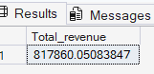
2. Average order value
SELECT SUM(total_price) / COUNT(DISTINCT order_id) as avg_order_value from pizza_sales
3. Total pizza sold
SELECT SUM(quantity) as total_pizza_sold from pizza_sales ;
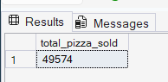
4. Average pizza per order
SELECT CAST(CAST(SUM(quantity) AS DECIMAL(10,2))/CAST(COUNT(DISTINCT order_id)AS DECIMAL(10,2))
AS DECIMAL(10,2)) FROM pizza_sales;
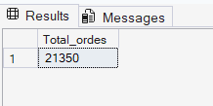
5. Daily Trends for Total Orders
SELECT DATENAME(DW,order_date) as order_day, COUNT(DISTINCT order_id) AS Total_orders FROM pizza_sales
GROUP BY
DATENAME(DW,order_date),
DATEPART(DW,order_date)
ORDER BY DATEPART(DW,order_date)
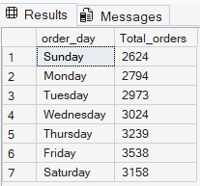

6. Monthly Trands for Total Orders
SELECT DATENAME(MONTH,order_date) as Month_name,COUNT(DISTINCT order_id) as Total_orders FROM pizza_sales
GROUP BY
DATENAME(MONTH,order_date)
ORDER BY
Total_orders DESC

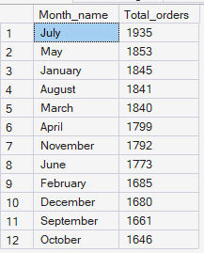
7. Percentage of Sale by Pizza Category
SELECT pizza_category,SUM(total_price) as total_sales ,SUM(total_price)*100/(SELECT SUM(total_price)
from pizza_sales)as PTC
FROM pizza_sales
GROUP BY pizza_category
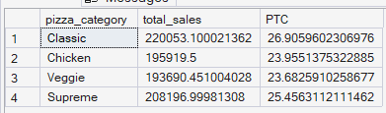

8. Percentage of Sale by Pizza Sale
SELECT pizza_size,CAST(SUM(total_price)AS DECIMAL(10,2)) as total_sales,CAST(SUM(total_price)*100/(SELECT SUM(total_price)
from pizza_sales)AS DECIMAL(10,2)) as PTC
FROM pizza_sales
GROUP BY pizza_size
ORDER BY PTC DESC
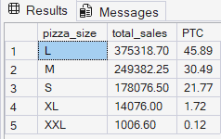
9. Top 5 Best Sellers by Revenue, Total Quantity and Total Orders
SELECT TOP 5 pizza_name,SUM(total_price) AS Total_revenue FROM pizza_sales
GROUP BY pizza_name
ORDER BY Total_Revenue DESC
